Before using Object.values() to turn state.object returned from api access into array for component

See state objects {1. {}, 2.{}…}

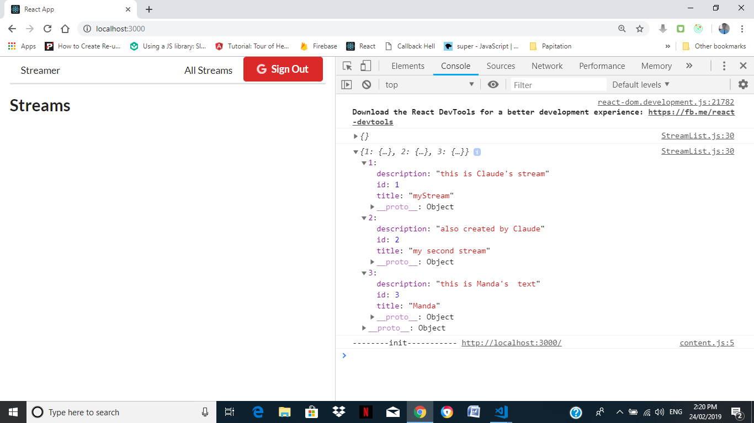

After using Object.values() which is JS function, why converting object base from api access into array ?

Using array base can map() to iterate streams to a list of stream.

Object base can’t use map()

